
National University of Technology

Machine Learning Lab- CS3504

LAB Submitted to:

Lec.Hajra Ahmad

Submitted By:
Muhammad Abdullah

Reg. No: F22607010
Batch: Fall AI 2022
Lab : 02
Q.NO.1:

import pandas as pd

df = pd.read_csv('employee_data.csv')

print(df.sample(5))

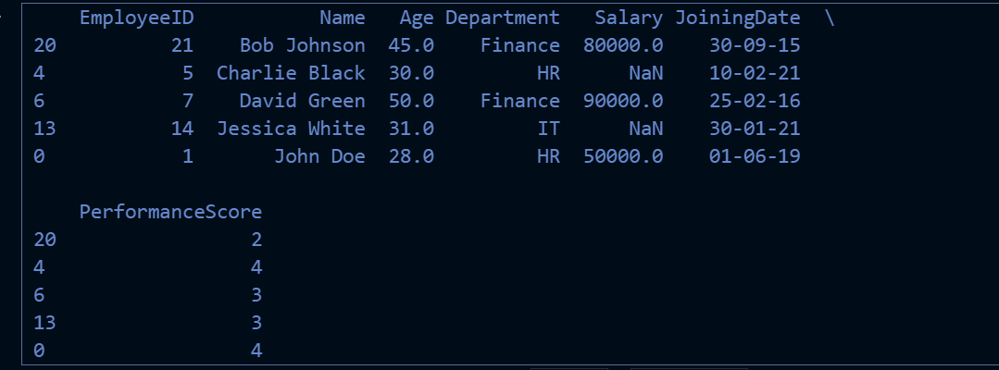
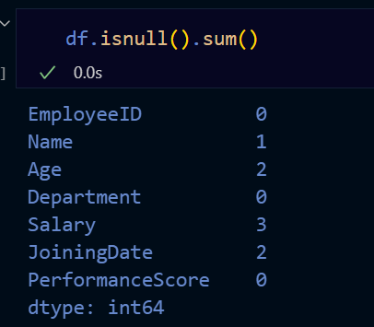

df = df.drop(index=7)
median_age = df['Age'].mean().astype(int)
df['Age'].fillna(median_age, inplace=True)

df.reset_index(drop=True, inplace=True)

df.to_csv('updated_file.csv', index=False)

print(df.sample(5))

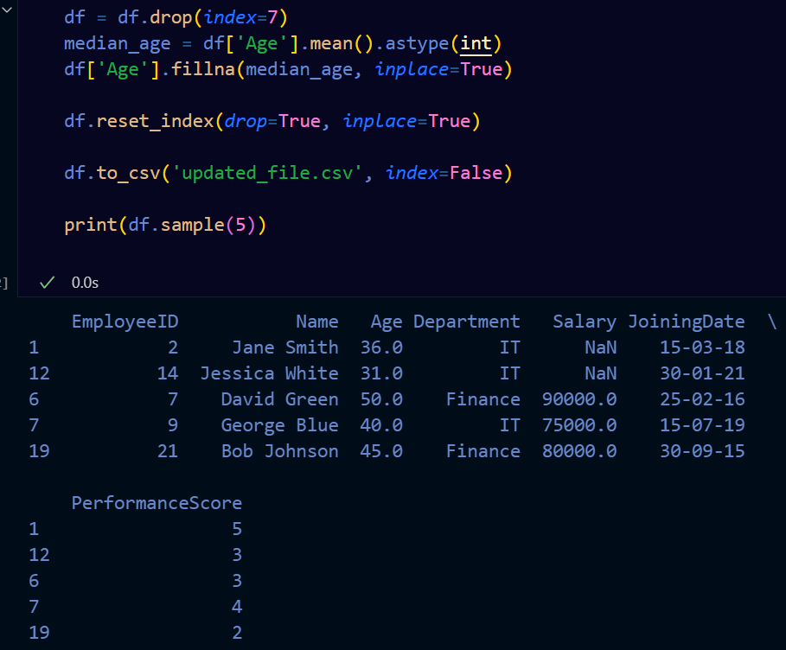

median_salaries = df.groupby('Department')['Salary'].mean().astype(int)

def fill_missing_salary(row):
if pd.isna(row['Salary']):
return median_salaries[row['Department']]
return row['Salary']

df['Salary'] = df.apply(fill_missing_salary, axis=1)

df.to_csv('updated_file.csv', index=False)

print(df)

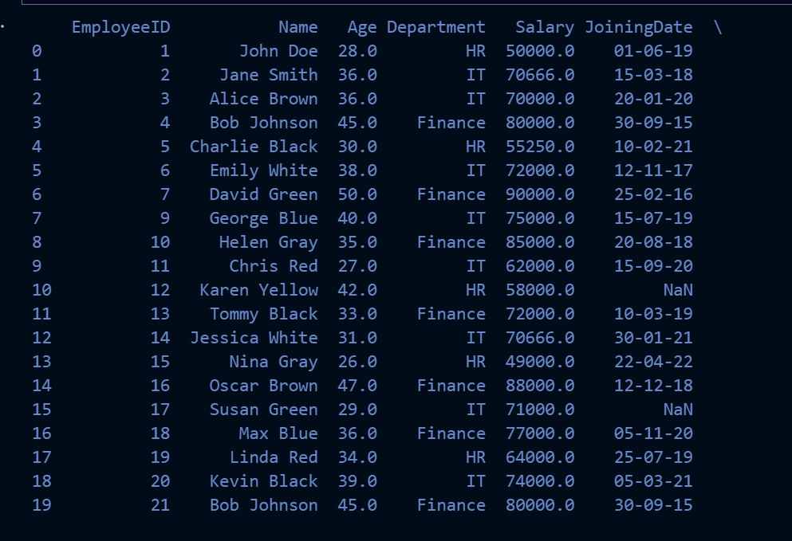

most_frequent_date = df['JoiningDate'].mode()[0]

df['JoiningDate'].fillna(most_frequent_date, inplace=True)

df.to_csv('updated_emoployees_data.csv', index=False)

print(df)

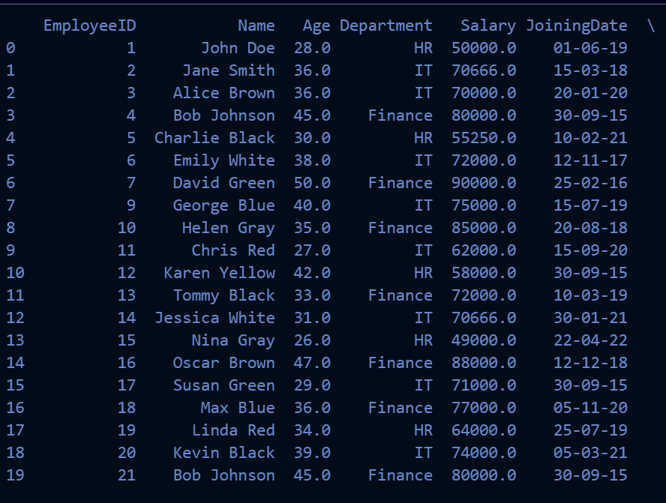

duplicate_rows = df[df.duplicated()]

duplicate_columns = df.columns[df.columns.duplicated()]

if not duplicate_rows.empty:
print("Duplicate Rows:")
print(duplicate_rows)
else:
print("No duplicate rows found.")

if len(duplicate_columns) > 0:
print("Duplicate Columns:")
print(duplicate_columns)
else:
print("No duplicate columns found.")



from sklearn.preprocessing import StandardScaler
scaler = StandardScaler()

df[['Salary', 'PerformanceScore']] = scaler.fit_transform(df[['Salary', 'PerformanceScore']])

df.to_csv('updated_file.csv', index=False)

print(df)

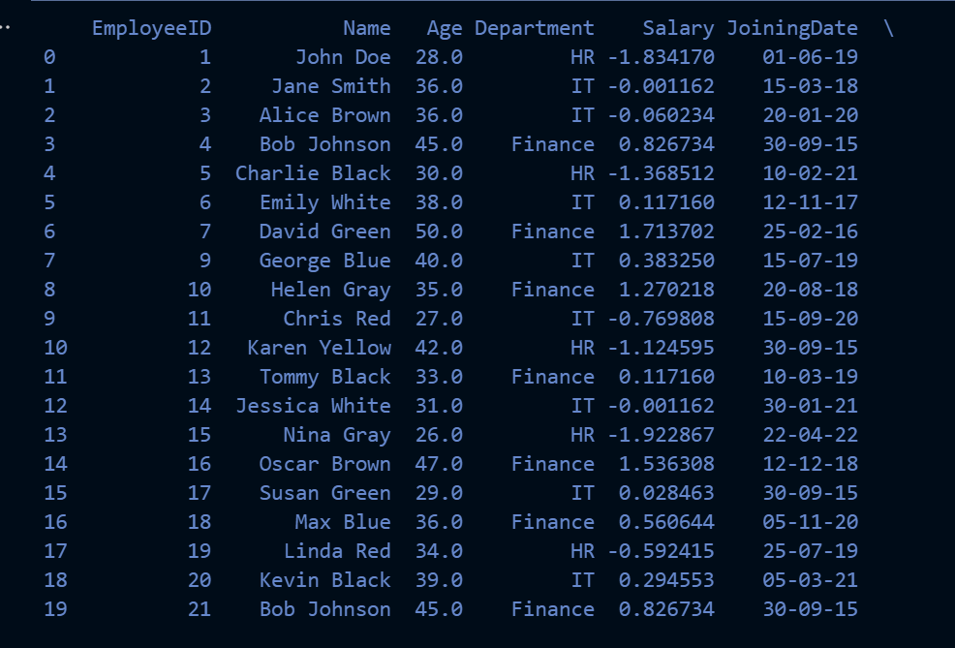

from sklearn.preprocessing import MinMaxScaler
scaler = MinMaxScaler()

df[['Salary', 'PerformanceScore']] = scaler.fit_transform(df[['Salary', 'PerformanceScore']])

df.to_csv('updated_file.csv', index=False)

print(df)

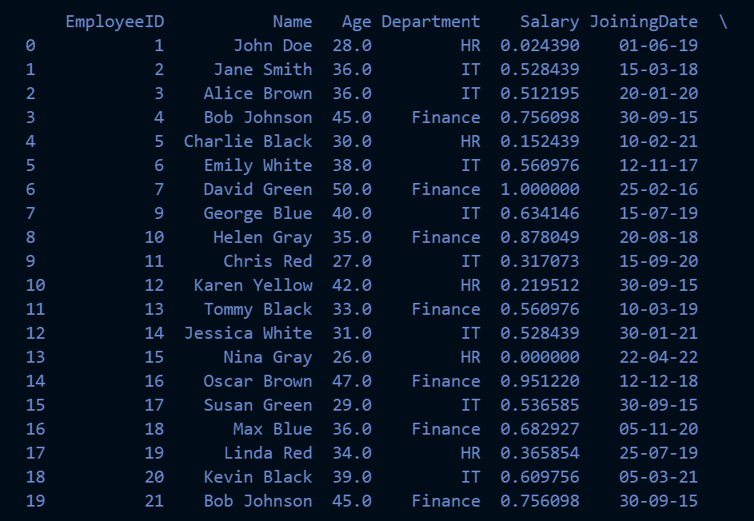

df_encoded = pd.get_dummies(df, columns=['Department'])

df_encoded.to_csv('updated_file.csv', index=False)

print(df_encoded)

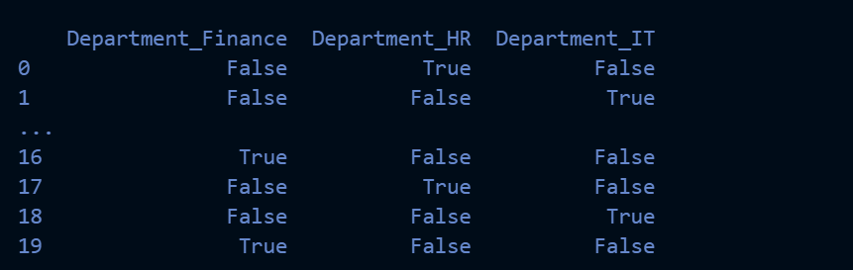

from datetime import datetime

current_year = datetime.now().year

df['YearsAtCompany'] = current_year - pd.to_datetime(df['JoiningDate'], format='%d-%m-%y').dt.year

df.to_csv('updated_file.csv', index=False)

print(df)



